**Proof by Induction**

# Natural Numbers

* If you want to prove P n for all n : ℕ, then it suffices to prove P 0, and that assuming P n, P (n + 1) holds.
* For example, defining an inductive **is-even** function:

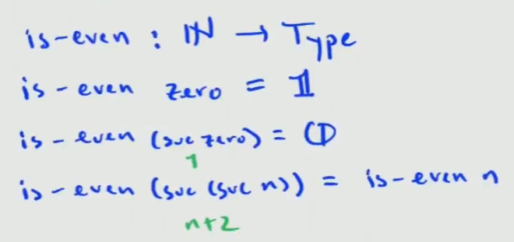

* As another example, defining an inductive proof that a number is either even, or is not even:

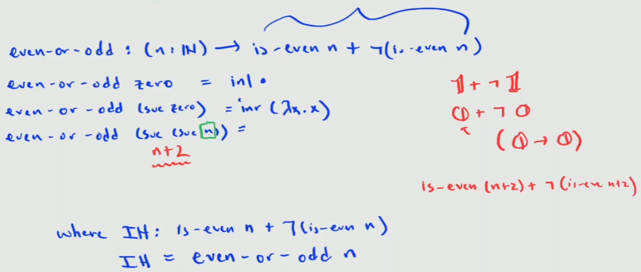

* Proving that n + 0 = n, using ap suc in the recursive proof:

